Laureate Declaration

Title of entry: ……………….
Category of entry: ……………….

I have included the required documentation and agree to the conditions and the privacy policy set up by Europa Nostra.

I confirm that as the entrant of a winning submission to the European Heritage Awards / Europa Nostra Awards 2024, I have obtained permission from the owners of the copyright, for Europa Nostra and the European Commission to freely use the photographs and material submitted (and others subsequently requested) for all purposes of communication, publication and promotion of the Awards.

Place: Cluj-Napoca
Date: 12.04.2023
Signature and stamp (if applicable):

Declaration by the Owner

I, Kalamár Gáspár Gábor, administrator of the Gavart Productions company., owner of the following materials: Templom Video 1.mp4, Templom Video 2.mp4, Templom Video Dron.mp4, Archive 1.mp4, Archive 2.mp4, Archive 3.mp4, Archive 4.mp4, Archive 5.mp4.……………………….., consent to the awarding of the above-mentioned property / project to the European Heritage Awards / Europa Nostra Awards 2024.

Place: Cluj-Napoca
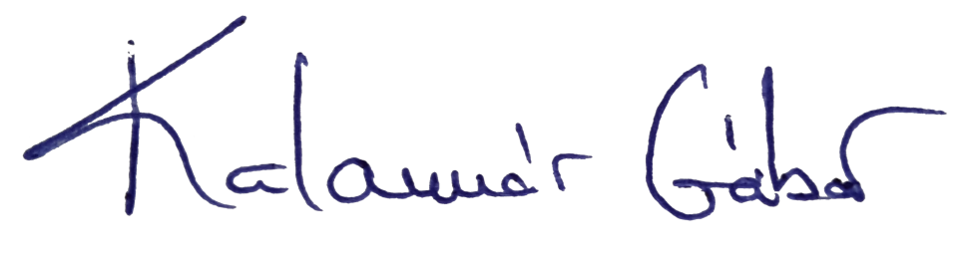
Date:12.04.2023
Signature


Stamp (if applicable):

Copyright authorisation (HIGHLIGHTED SECTIONS MUST BE COMPLETED)
This form should be completed only by entrants for submissions referring to buildings, collections of works and other tangible heritage assets.

The Licensor: | Name: Kalamár Gáspár Gábor, Gavart Productions SRL company  Address: str. Gheorghe Dima nr. 15/ ap. 3, Cluj Napoca, Romania  Function: administrator  [state here the name of the person who has the rights to the building / site / work of art]
Upon request from Europa Nostra, having its seat at Lange Voorhout 35 NL - 2514 EC The Hague, acting for its own benefit and for the benefit of its partner in implementing the Awards scheme (hereinafter referred together as "the Licensees");

And with reference to the work (hereinafter the "Work"):
Author(s): Kalamar Gaspar Gabor, Geiger Eduard

[original author, such as architect, painter]

Title or description:

[in case the Work is a building, this authorisation covers its image, both inside and outside, unless otherwise detailed]

Hereby:
- Subject to the conditions hereinafter specified, grants to the Licensees a royalty-free, non-exclusive authorisation to reproduce, extract, print, publish, make available the Work or parts thereof on any media, including print, digital and electronic forms. The Licensor also licenses to the Licensees the right to integrate and incorporate the Work or parts thereof into any existing or future work, as well as the right to store and archive the Work in any form or medium. This authorisation also includes the right for the Licensees to grant any of the rights stipulated before to third parties.
- All intellectual property rights in the Work - including but not limited to patent, trademark rights and copyright - rest exclusively with the Licensor.
- The Licensees commit themselves to acknowledge the Licensor, whenever possible, as follows:

Saint Michael Romano-Catholic Parish Church - Cluj-Napoca

[state here above the mention requested by the Licensor, e.g. © John Smith, 2024]

- The present authorisation is unlimited in time and space.
- The Licensor warrants that it has the full right and title to license directly to the Licensees the rights stipulated herein.
- Rights and liabilities of the parties, insofar as they are not expressly covered by this authorisation, shall be established according to the law of the European Union and, where necessary by the substantive law of Belgium. Any dispute, whether as to the express terms of this authorisation or otherwise, shall be determined by the competent court of Belgium.

Place: Cluj Napoca
Date: 12.04.2024
Signature
Stamp (if applicable)
Copyright authorisation (HIGHLIGHTED SECTIONS MUST BE COMPLETED)
This form must be completed by all photographers for all winning projects.

 | The Licensor - Photographer: | Name:  Address:  [state here the name of the photographer or person that has the rights to the photos]
Upon request from Europa Nostra, having its seat at Lange Voorhout 35 NL - 2514 EC The Hague, acting for its own benefit and for the benefit of its partner in implementing the awards scheme (hereinafter referred together as "the Licensees");

And with reference to the work (hereinafter the "Work"):
Author(s): [name of photographer]
Title or description:
[state the specific building / project for which the photos were taken. In case the Work is a building, this authorisation covers its image, both inside and outside, unless otherwise detailed]
Photographs taken:
[state here the photos taken]

Hereby:
- Subject to the conditions hereinafter specified, grants to the Licensees a royalty-free, non-exclusive authorisation to reproduce, extract, print, publish, make available the Work or parts thereof on any media, including print, digital and electronic forms. The Photographer also license to the Licensees the right to integrate and incorporate the Work or parts thereof into any existing or future work, as well as the right to store and archive the Work in any form or medium. This authorisation also includes the right for the Licensees to grant any of the rights stipulated before to third parties. These rights are always in connection to the Awards scheme and, whenever possible, upon prior communication with the Photographer.
- All intellectual property rights in the Work - including but not limited to patent, trademark rights and copyright - rest exclusively with the Licensor – Photographer
- The Licensees commit themselves to acknowledge the Photographer, whenever possible, as follows:

......................................................................

[state here above the mention requested by the Photographer, e.g. : © John Smith, 2024]

- The present authorisation is unlimited in time and space.
- The Photographer warrants that it has the full right and title to license directly to the Licensees the rights stipulated herein.
- Rights and liabilities of the parties, insofar as they are not expressly covered by this authorisation, shall be established according to the law of the European Union and, where necessary by the substantive law of Belgium. Any dispute, whether as to the express terms of this authorisation or otherwise, shall be determined by the competent court of Belgium.

Place:
Date:
Signature:
Note: Please copy and paste this section if more than one photographer is involved in the project.

